Clinical Briefing Outline

Executive Summary
- Problem in plain language
- Recommended solution
- Expected impact (clinical, operational)

1. Background
- Why this problem matters now
- Who is affected (patients, clinicians, organization)
Osteoarthritis is a leading cause of disability worldwide, currently affecting approximately 250 million people, with its prevalence rising due to an aging and increasingly obese population. In England and Wales alone, around 160,000 hip and knee replacement procedures are conducted annually to address this burden. This problem matters now because traditional medical management is often reactive; however, there is a critical shift toward shared decision-making (SDM), which seeks to improve care and reduce costs by integrating clinical evidence with patient preferences. To support this approach, accurate prediction models are necessary to navigate the wide variation in surgical outcomes and foster the advancement of precision medicine.
Multiple stakeholders are deeply affected by the outcomes of these orthopedic procedures. Patients undergo surgery primarily to improve their health-related quality of life, yet they require highly accurate, individualised predictions to set realistic expectations and avoid dissatisfaction. Clinicians need these data-driven tools to complement their professional expertise, enabling them to inform patients more precisely about the likely success of a procedure. Furthermore, organizations such as the National Health Service (NHS) are affected because they utilize patient-reported outcome measures (PROMs) to monitor the quality of care and manage the significant direct and indirect socioeconomic costs associated with treating end-stage osteoarthritis.

2. Problem Statement
- The Problem
- Clinical Consequences
Despite the high volume of orthopedic surgeries conducted to treat the condition, traditional clinical management remains largely palliative and reactive, often failing to utilize shared decision-making (SDM) to tailor treatments to specific patient needs. These management gaps result in devastating clinical consequences, including persistent pain and disability for up to 25% of patients one year post-surgery, which leads to widespread patient dissatisfaction and diminished health-related quality of life. Ultimately, the absence of individualized, data-driven prediction models prevents the realization of precision medicine, incurring substantial socioeconomic costs through high medical expenditures and indirect burdens such as work loss and premature retirement.

3. Project Value & Objectives
- Project Scope
- Business Value
- DAPS diagram
Project Scope
This data science project evaluated the performance of X supervised machine-learning classifiers to predict binary postoperative improvement following surgery. Utilizing a massive NHS dataset of over X observations, the researchers demonstrated that advanced algorithms—most notably extreme gradient boosting—can outperform traditional linear models in predictive accuracy. The study revealed that preoperative scores, including the generic visual analogue scale (VAS) and disease-specific Q scores (Oxford Hip and Knee scores), are the most critical predictors of a patient's postoperative health state. By establishing these robust, real-world benchmarks, the project provides a framework for integrating individualized outcome estimations into routine clinical practice

Business Value
Our main goal is to reduce the amount of clinically ineffective surgeries for hip or knee joint replacements by predicting which patients will report pain and disability 1 year after the surgery. This enables a range of advantages:

• Proactive identification of patients who will likely not benefit from this surgery before surgery takes place.
• Informed clinical decision-making to potentially avoid unnecessary procedures
• Patients avoid an invasive procedure that is less likely to be clinically effective for them and can be directed toward alternative treatments that do have a higher chance of success.
• Significant cost effective for the healthcare system by reducing clinically ineffective surgeries.
• More efficient use of healthcare resources. Decreasing the amount of clinically ineffective surgeries you free capacity for patients who will genuinely benefit. This consequently will improve wait times.
• Hospital and surgical department improve their outcome statistics and reputation.
• Reducing low value care aligns with medical ethics: do no harm.
• Standardization: The predictive tool creates more consistency in decisions, this standardization will reduce unwarranted variation between clinicians.

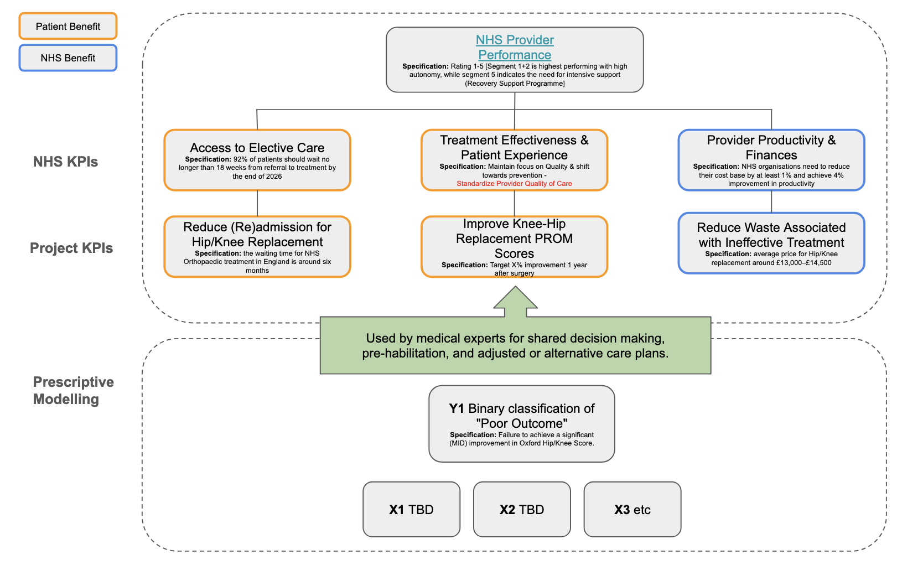

4. Methodology
- Data sources used
- Data is appropriate and reliable
- How insights are generated
5. Validation & Performance Metrics
- How success was measured
- Key results
- Limitations and known risks

6. Recommended Solution
- Present solution
- How it supports decision-making
- Where it fits into existing workflows

7. Implementation Plan

Clinical Integration

Clinical Safety & Ethics

8. Appendix
- Data Selection Process
- Feature selection
- Model architecture
- Full performance metrics

Core Roles
Role | Team Member | Responsibilities
Business Lead | Mendel | Business requirements, stakeholder communication, value delivery
Data Lead | All Team Members | Data collection, quality assurance, feature engineering
Model & Evaluation Lead | All Team Members | Model development, hyperparameter tuning, performance evaluation
Explainability Lead | All Team Members | Model interpretation, analysis, documentation

HS Oversight Framework 2025/26: https://www.england.nhs.uk/long-read/nhs-oversight-framework-2025-26/

Operational Planning Guidance:
https://www.england.nhs.uk/long-read/2025-26-priorities-and-operational-planning-guidance/

Reforming Elective Care:
https://www.england.nhs.uk/long-read/reforming-elective-care-for-patients/

